No. of people taking a particular course.

1. CREATE TABLE tab1

(emp_name string, unit string, exp int, location string)

Row format delimited

Fields terminated by ‘,’;

2. LOAD DATA LOCAL INPATH ‘/home/acadgild/hive/emp.txt’ INTO TABLE tab1;

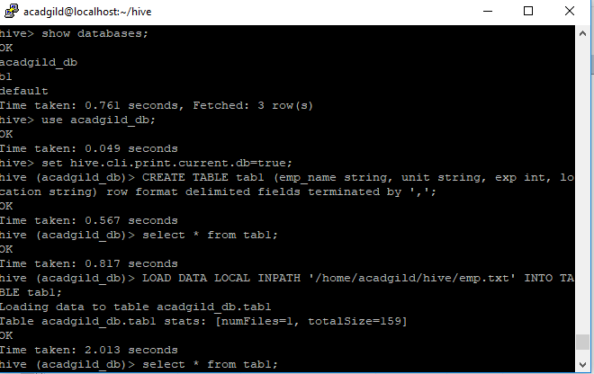

3. SELECT unit, count(*) from tab1 GROUP BY unit;

